**CS 355 Midterm Notes:**

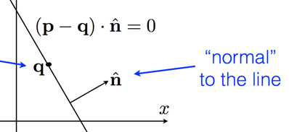Raster Images:

Size: number of pixels (height X width)

Bit Depth: bits of precision for each pixel

2-bit gray – 4 shades

8-bit gray - 256 shades

12-bit – X-rays / CT

24-bit color – 8 bits each of R, G, B

Interlacing: Send half screen 60X/second

Color Buffers are faster with Word aligning, so we fill the last slot with ALPHA!

Double Buffering:

Draw to offscreen buffer, then copy buffer

Circles:

X­­­­2 + Y2 = r2

Ellipses:

(X/a)2 + (Y/b)2 = r2

100% saturation is pure color. No white, black, or gray.

Vector is a directional quantity without a specific location. Direction, and Magnitude (length, norm).

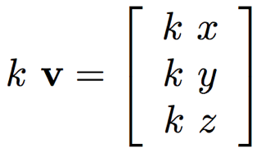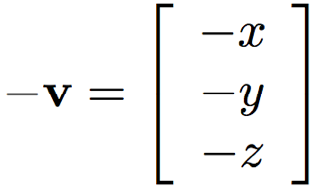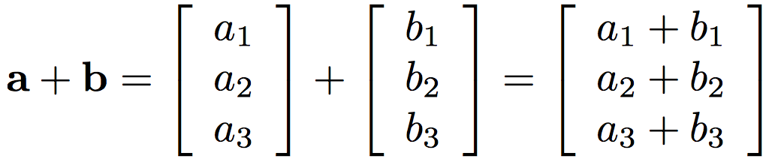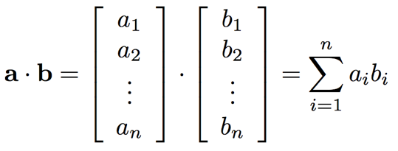

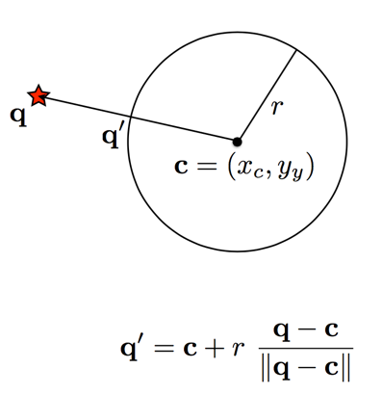Vectors whose dot product is zero are said to be orthogonal

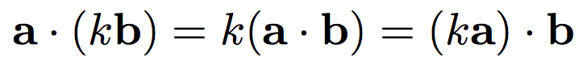

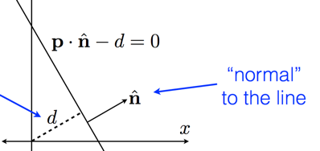Implicit:

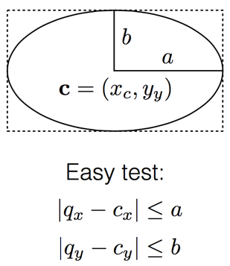

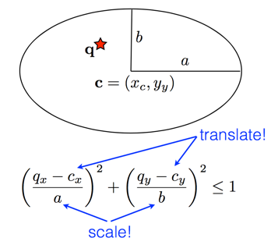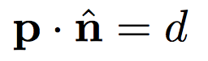Normal and distance:

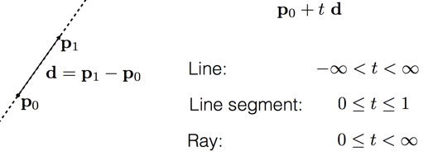Implicit: Parametric:

World Space:

* Choice of origin and cooridinate system is arbitrary
* Where objects live

Object Space

* Coordinate system used to define objects
* Also arbitrary, but make it simple

Giving an object a Location, Orientation, and Size is what places it into world space (object to world)

Giving the world a location, orientation and size define a world to view transformation

--Object Coord 🡪 World Coord 🡪 View Coord

In object to world, First Rotate, Then Translate!

In world to object, First Translate, Then Rotate!

Selection:

Before testing a click, convert to the appropriate space. Screen to world, world to object. Test in object space.

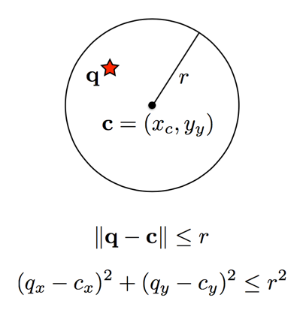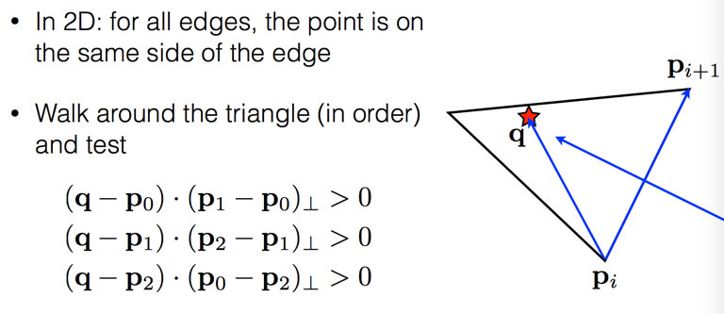To get a perpendicular vector, swap x and y and negate one of the two.

